**Lab Exercise 5–Provisioning an S3 Bucket on AWS**

**Exercise Steps:**

**Step 1: Create a New Directory:**

Create a new directory to store your Terraform configuration:

mkdir Terraform-S3-Demo

cd Terraform-S3-Demo

**Step 2: Create the Terraform Configuration File (main.tf):**

Create a file named main.tf with the following content:

terraform {

required_providers {

aws = {

source = "hashicorp/aws"

version = "5.31.0"

}

}

}

provider "aws" {

region = "us-east-1" # Replace with your preferred region

access_key = "your IAM access key" # Replace with your Access Key

secret_key = "your secret access key" # Replace with your Secret Key

}

This file sets up the Terraform AWS provider.

**Step 3: Create a Terraform Configuration File for the S3 Bucket (s3.tf):**

Create another file named s3.tf with the following content:

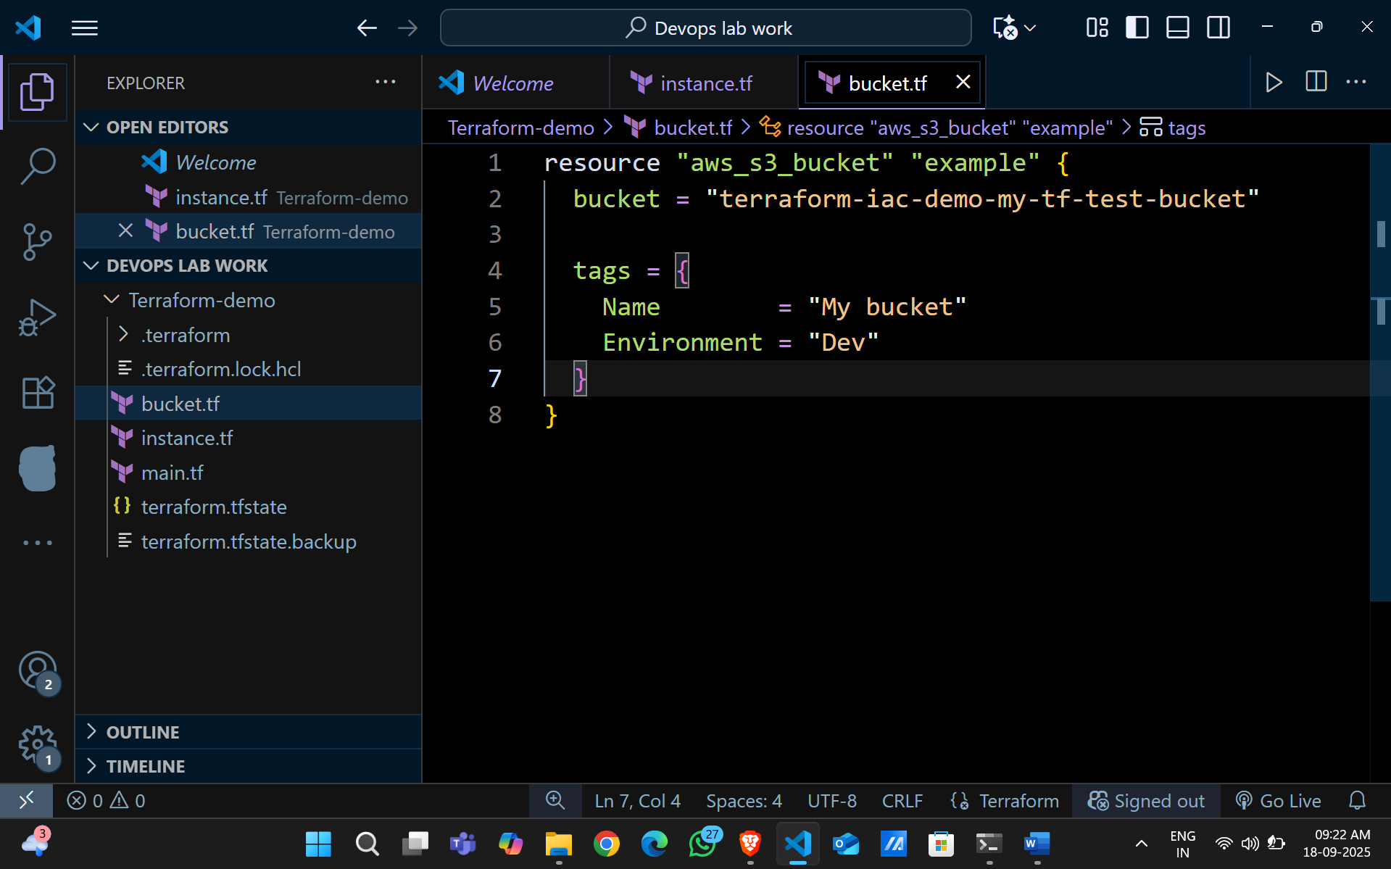

This file provisions an S3 bucket with a unique name using a random string suffix.

**Step 4: Initialize Terraform:**

Run the following command to initialize your Terraform working directory:

terraform init

**Step 5: Review the Plan:**

Preview the changes Terraform will make:

terraform plan

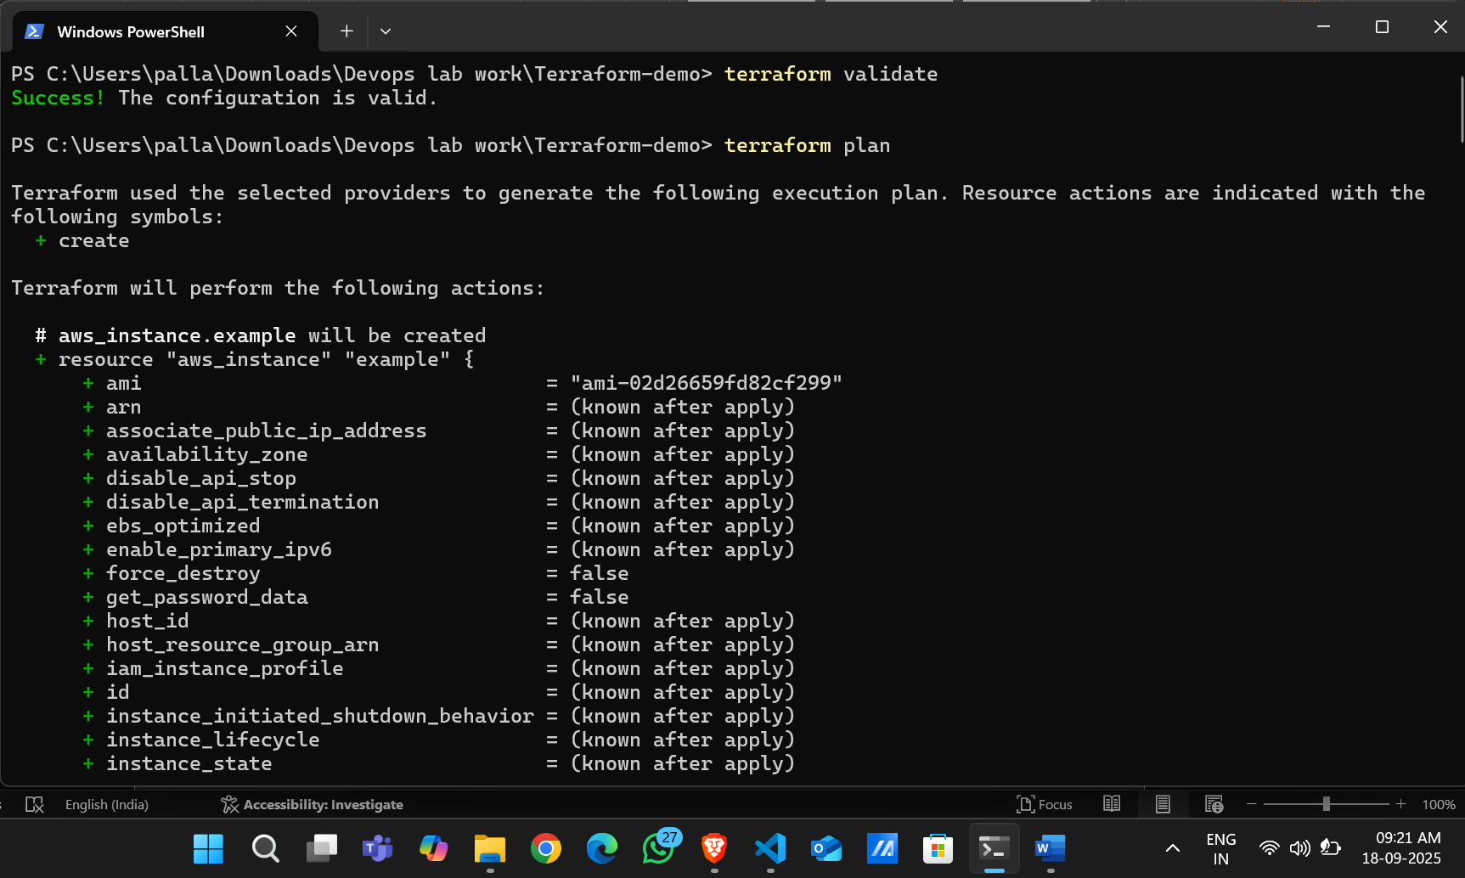

Review the output to ensure it meets your expectations.

**Step 6: Apply the Changes:**

Create the resources:

terraform apply

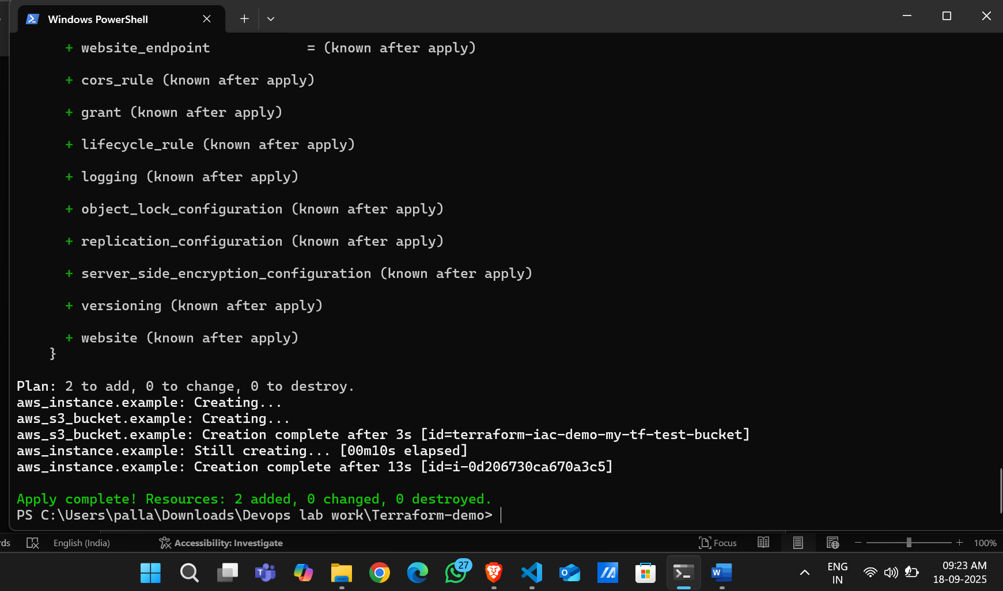

**Step 7: Verify Resources:**

1. Log in to your AWS Management Console.
2. Navigate to the **S3** dashboard.
3. Verify that the S3 bucket has been created with the specified configuration.

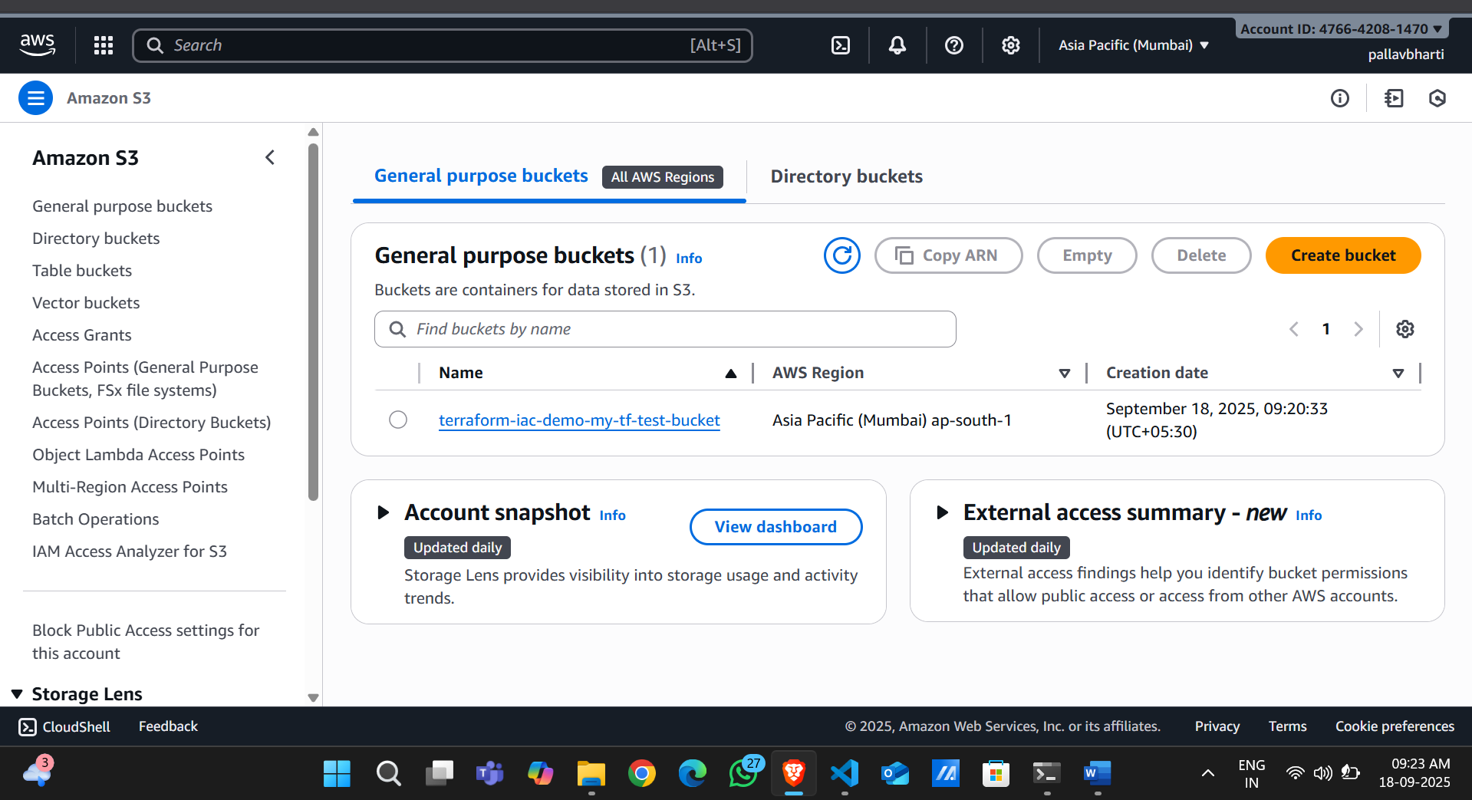

**Step 8: Cleanup Resources:**

To remove the resources created, run the following command:

terraform destroy

When prompted, type yes to confirm.

